**Structural Defects**

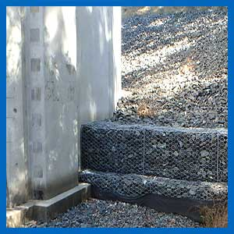

Look for evidence of sunken roof areas, cracked sheeting, increased flexibility or movement in the framing.  
  
This can indicate loose or missing internal fixings, cracked or broken welds on main rafters or supporting wall brackets.  
  
Work carried out after a new tank is constructed can often cause serious structural defects to develop. Back-filling up against lower wall areas can create a transfer of stress to other parts of the tank, that were not allowed for in the engineering design This can reduce the life expectancy of the asset and require significant remedial works to be carried out.