**Site Records**

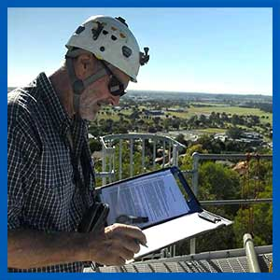

Having a sequential series of photographs can assist with further assessment of a developing issue, or provide supporting evidence for the programing of rectification works. Collecting a series of photos of the same feature/fixture from the same profile, can give a representation of the degradation or increasing severity of an issue over time.  
  
Many maintenance issues have a commonality amongst similar designs and types of machinery.

By recording all the static data such as motor and pump brands, seal and coupling types, an identified failure can often lead to developing issues amongst the other similar pumping units. A search and tracking facility within the data storage system can save valuable time in avoiding expensive and time consuming equipment failures before they occur.