**Water Quality Impacts 2**

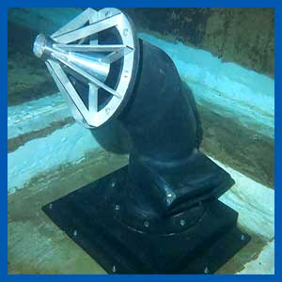

Water needs to be constantly moved about and blended to maintain quality and disinfection residuals.  
  
Internal pipework configurations will not always achieve these outcomes, so addition mixing by mechanical means is desirable. There are many options available, along with various claims of performance and outcomes.

The ‘KIS principle’ (keep it simple) is often overlooked in the process, but there are simple things that can be done to improve water quality and they can also be reasonably priced and easy to maintain.  
  
Divers can determine when the water inside tanks is stale and not turning over as required. Evidence within sediment layers, algae deposits on walls and poor flow direction as shown by staining or sediment patterns on the floor.