**Overflow Drain Points 2**

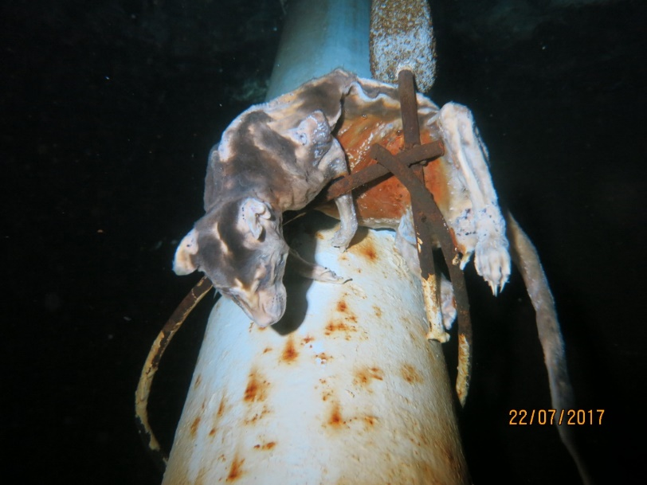

The overfilled water needs a clear area to disperse, so the pipework is usually located a distance from the tank and often becomes overlooked as a source for potential contamination during inspection or maintenance projects.  
  
Animals have been known to make their way into the tank through this unsealed pipe area. This feral cat entered up through the external pipework, fell into the tank and drowned. He dropped down and became caught on the overflow CP anode bracket, otherwise the dead body would have been assumed to have entered from somewhere else within the tank.