**Overflow Drain Points**

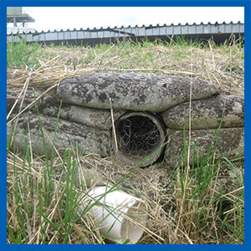

It is essential for storage tanks to have an overflow system installed for when the tank is accidentally overfilled.  
  
Because overflow events are rare, animals such as rabbits, feral cats, snakes, rats/mice and frogs often begin living inside the pipework as it is a sheltered environment.