**Roof drain points 1**

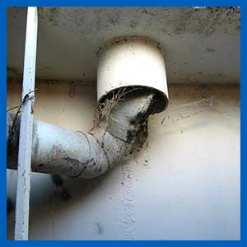

Roof drain points can look effective from the surface, but they need to be inspected from the underside areas, to ensure they are properly sealed and connected into the relevant pipework, which normally leads to the overflow bell mouth area. Otherwise, all the roof area is draining contaminants directly into the stored water.