**Water Quality Impacts**

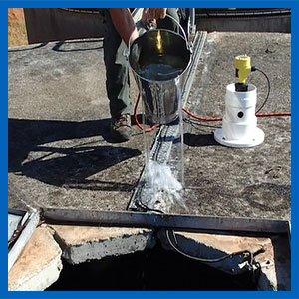

Inspect areas around platforms, entry hatches and roof fixtures for poor drainage by doing a ‘bucket of water’ test.  
  
Pour water around ‘sealed’ areas, then look and listen inside the tank for evidence of water leaking back in.  
  
Do this test after any upgrades to the roof area.

Platform and hatch areas are the most common places where contaminants enter into storage tanks.  
  
Potable water should be recognised as a food grade product and its storage facilities treated the same as if they contained milk, wine or grain.  
  
In the latter cases, it would be totally unacceptable if external contaminants such as storm water, bird faeces or dust were allowed to enter and mix with the stored product.