**Ventilation 2**

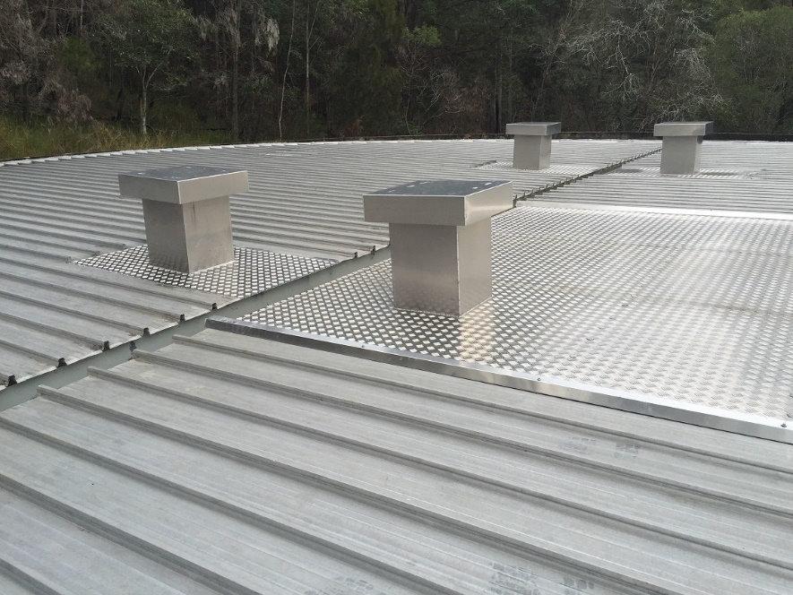

Ventilation systems on tanks in known windy environments or in areas subject to historical vandalism events need to have a more solid and vandal proof system of providing air flow within a tank. And airflow needs to be designed so that it can enter around the upper wall areas through secure, vermin proof mesh panels and then be extracted from the roof area fixed vents. If there is a known local dust, strong wind area or other environmental issue, be sure to limit the side wall vent areas away from this contamination source.