Safety Screens 2

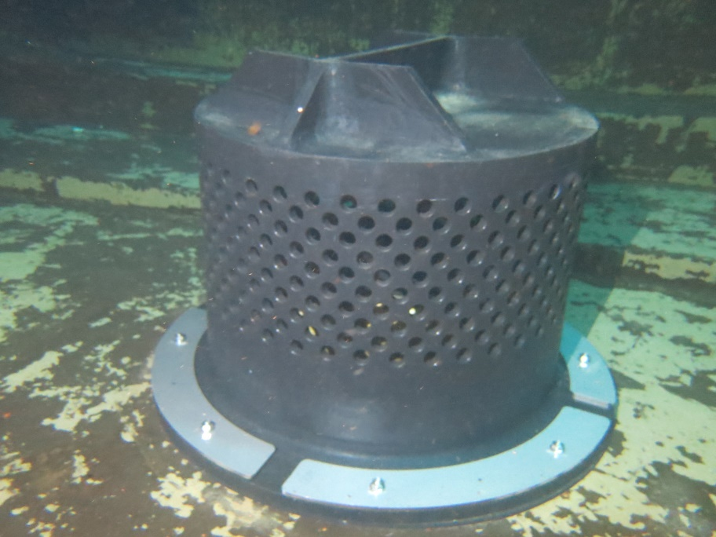

Well designed and fitted screens prevent sediments from entering the downstream reticulation system. Many screens are too large in their surface area and allow sediments to accumulate around the external sections during periods of low flow, but then to be sucked into the reticulation system during high flow events. Many outlet systems are also too close to the floor, causing local sediments to be drawn into the pipework. Outlet screens should fit closely around the penetration, have a raised and sealed base area of at least 100mm high and have suitably sized holes making up 120% of the outlet size. This allows the screen to be ‘self-cleaning’ during normal flow events. A larger number of holes reduces the surface flow rate and sediments will accumulate and be drawn in during high outlet flows.