**Corrosion**

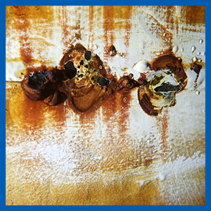

Corrosion within a water storage tank will introduce contamination to the supply, depending on the amount of water exposed to this issue. It will also reduce disinfection levels if left unchecked.

Corrosion defects are most relevant in concrete tanks where ductile iron pipework is often left un-coated and corrodes significantly over time. Galvanised fixtures such as roof support posts, ladders and support brackets are also subject to serious corrosion issues when immersed in water.