**Security**

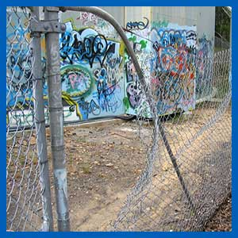

If vandals access sites on a regular basis and there is evidence of unauthorised access to the roof area, then the overall risk rating for the tank is ROL (running on luck!) for potential water quality impacts, structural or fixture damages. Every possible step needs to be taken to eliminate unauthorised access to site and deter any unwanted visits.  
  
Use security cameras, maintain secured compounds and install access doors, ladders and hatches that are sturdy and locked. Also ensure the site is checked regularly by operational staff.

Access by known persons such as Teleco contractors or neighboring property owners should be documented.  
  
Site works should be monitored to ensure that structural issues have not been created or the stored water in the tank has not been exposed to contamination impacts.